**CHAPTER IV - RECOMMENDTION**

**4.1 Proposed System Flowchart**

**(Refer to INDEX B at INDEXES)**

**4.1.1 Proposed Icon-Based Presentation**

**(Refer to INDEX C at INDEXES)**

**4.2 Graphical User interface**

**Log in**

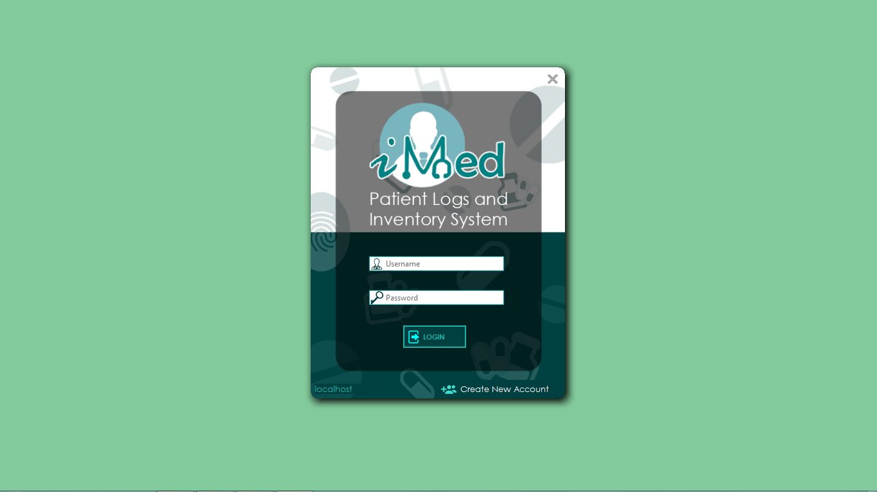

**New Account Registration**

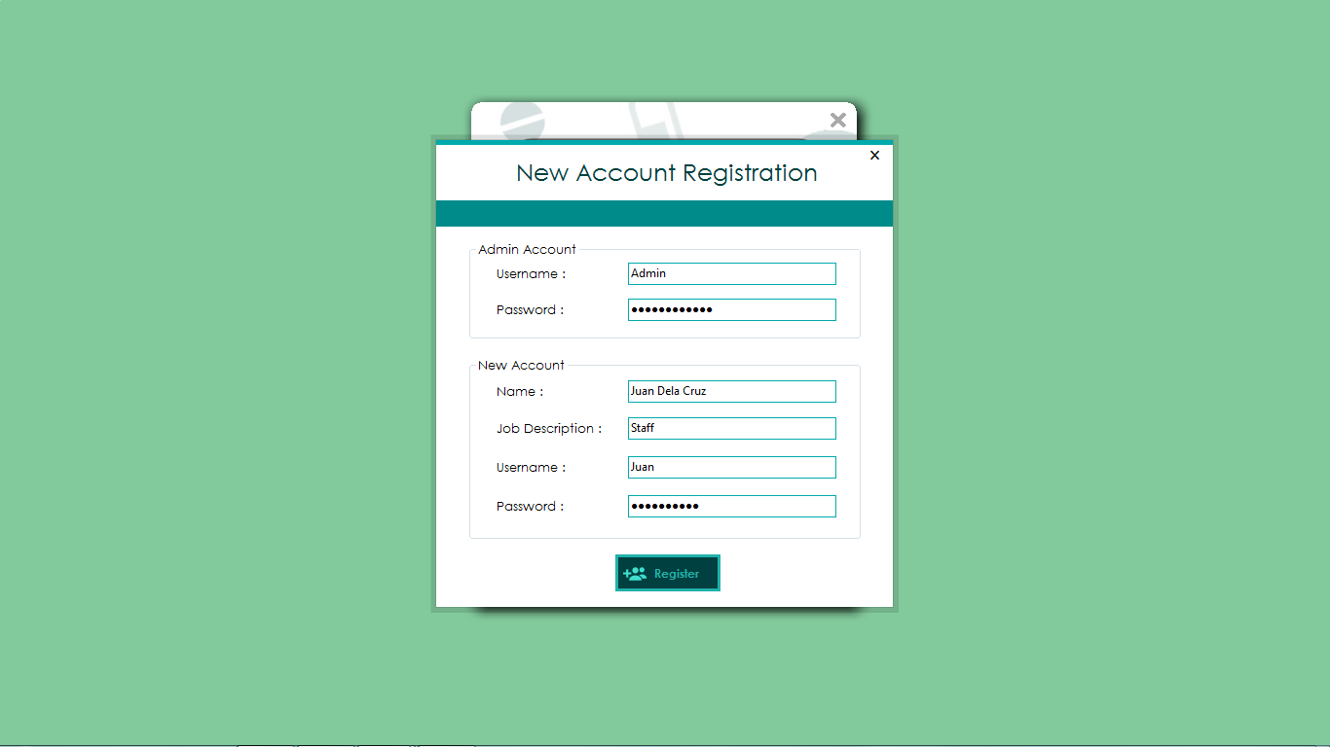

**Main Form**



**Navigation Pane**



**Medicine Form**

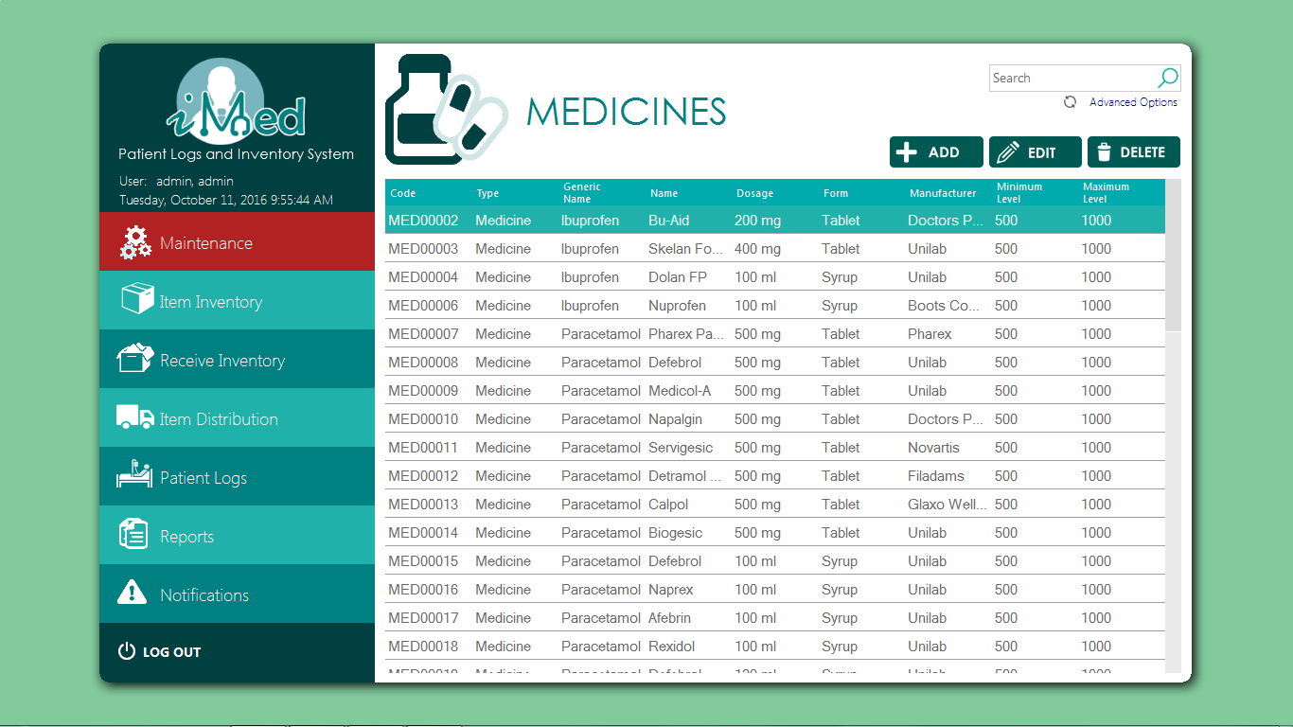

**Add Medicine Form**

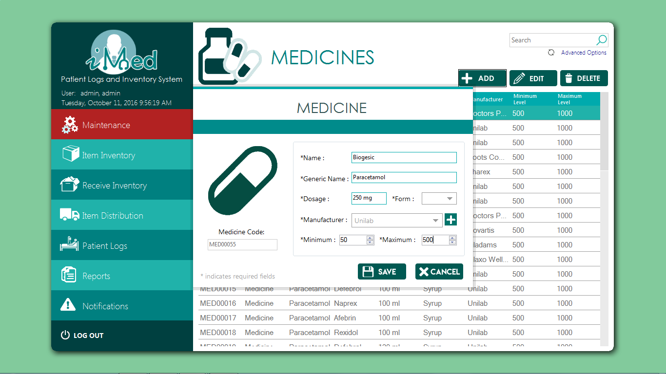

**Supply Form**

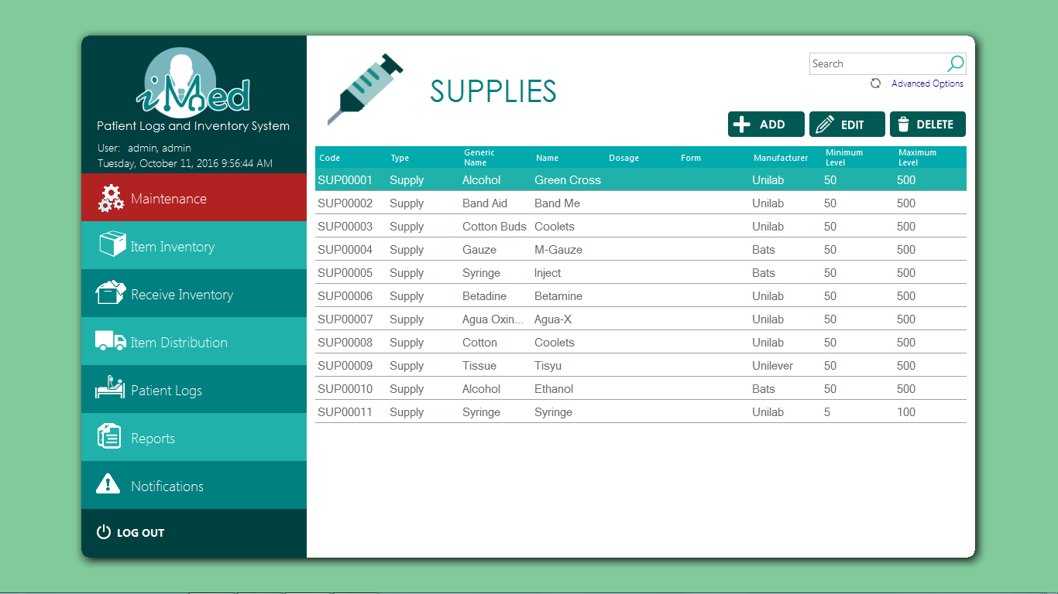

**Add Supply Form**

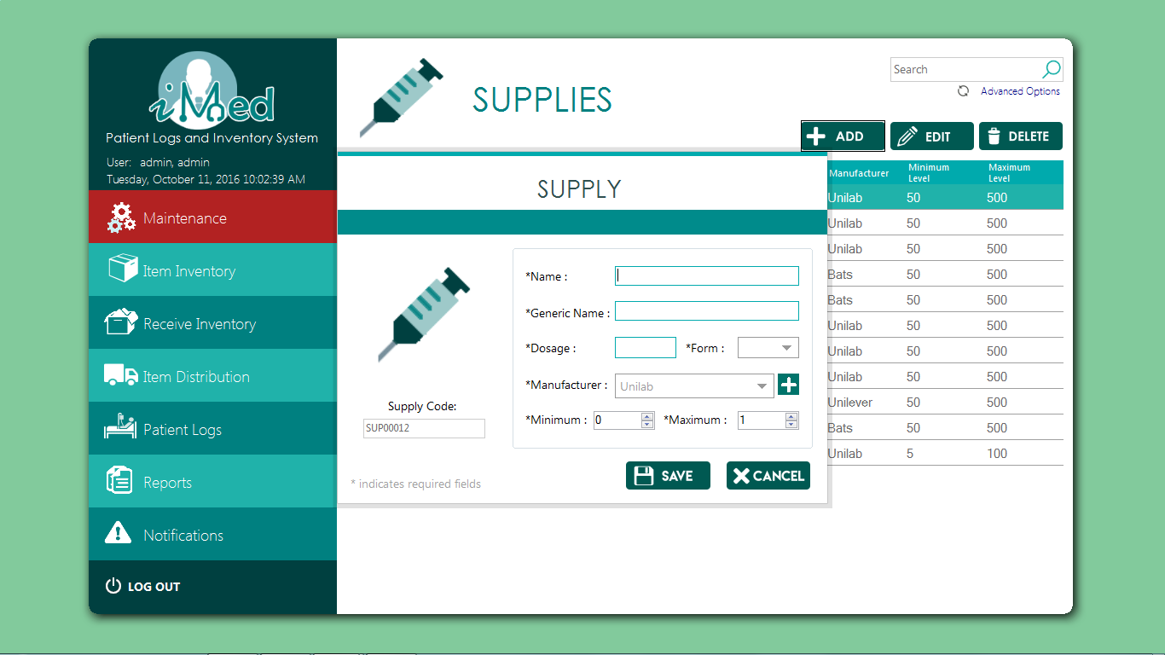

**Equipment Form**

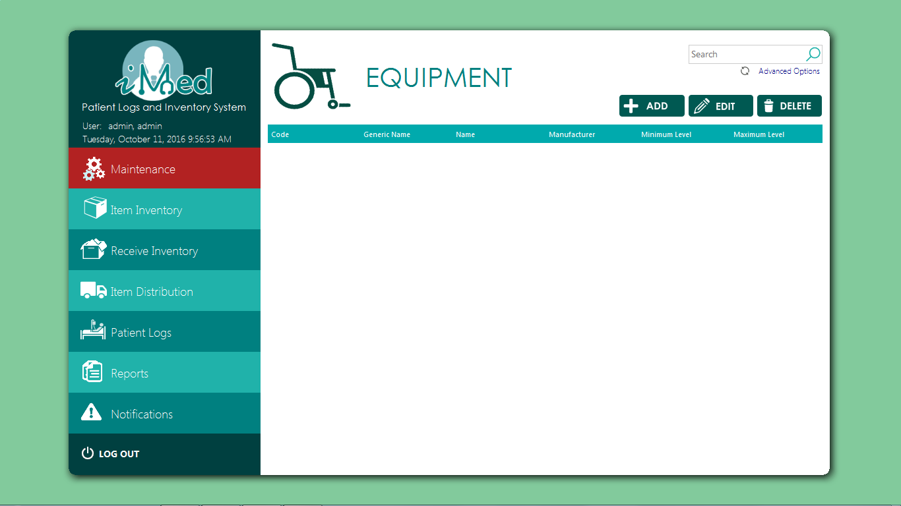

**Add Equipment Form**

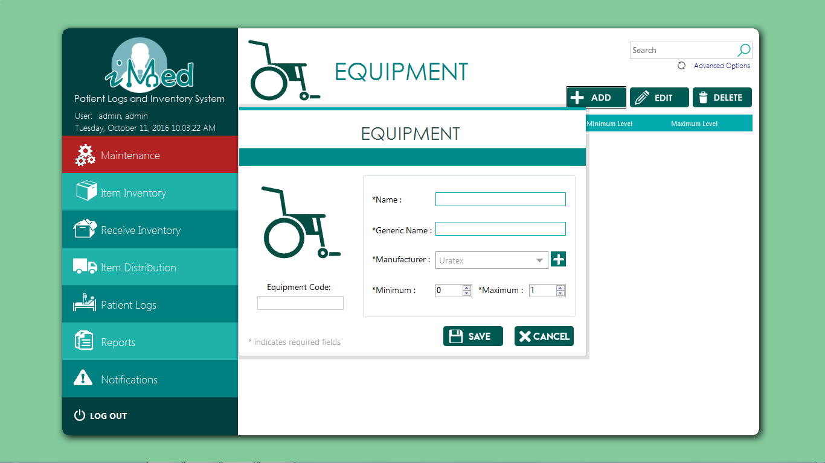

**Student Records Form**

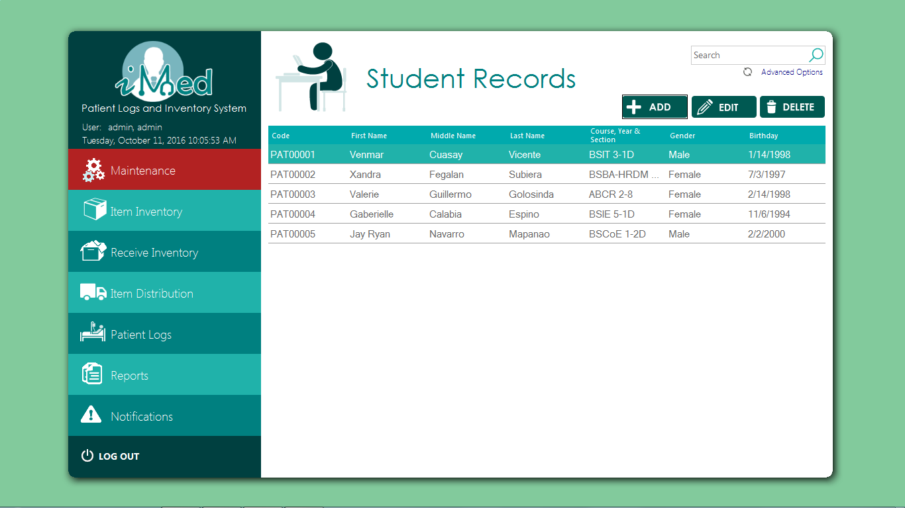

**Patient Registration Form**

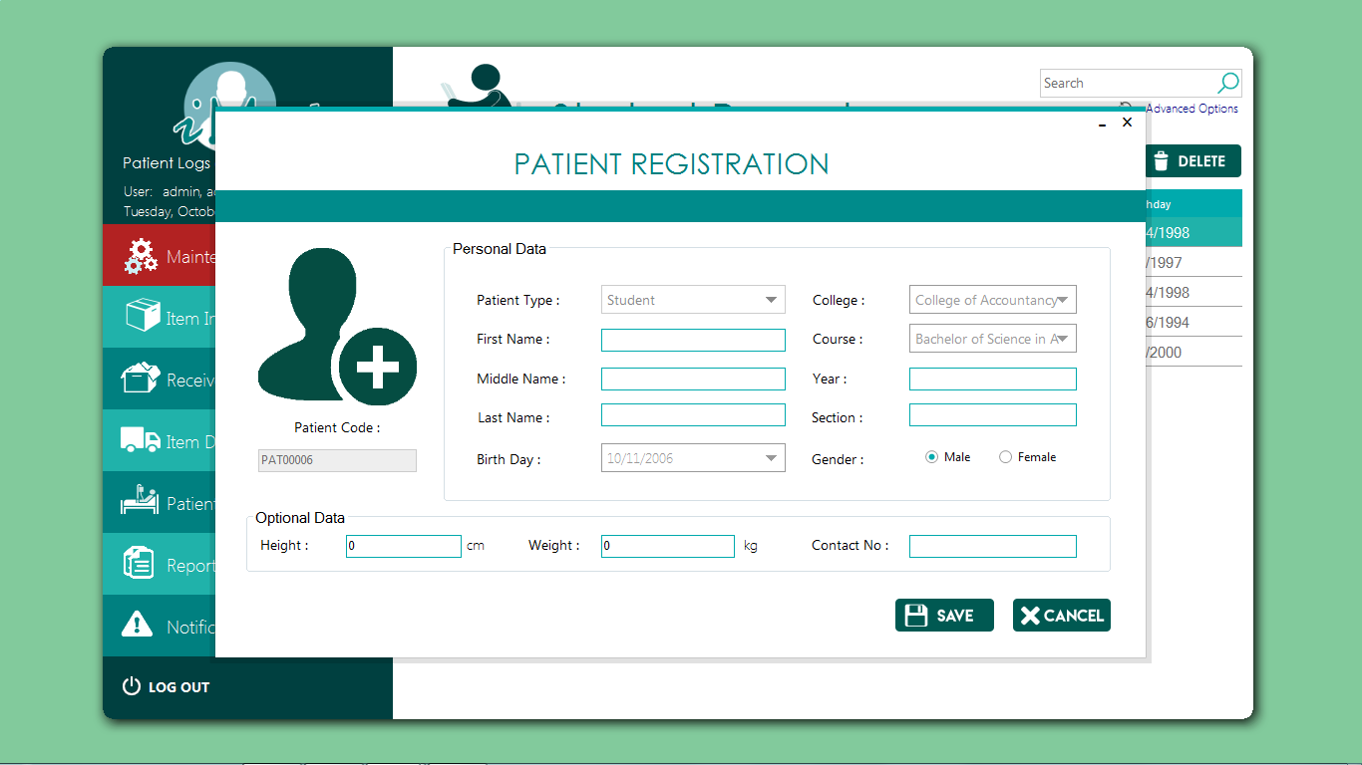

**Faculty Records Form**



**Admin Records From**

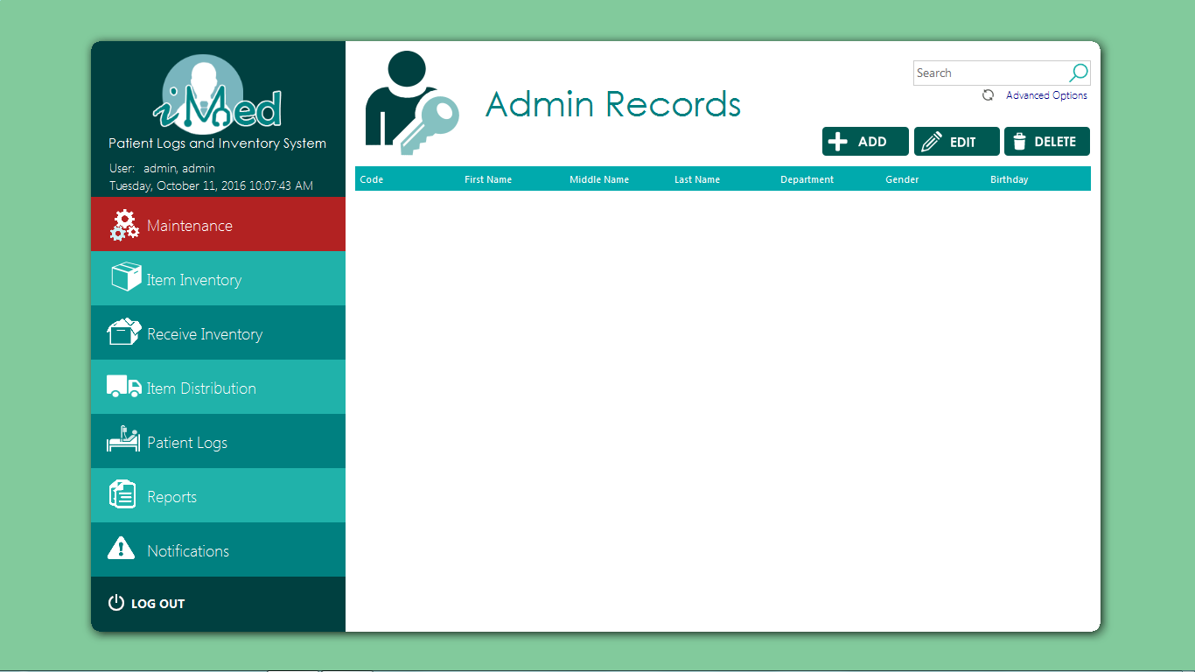

**Supplier From**

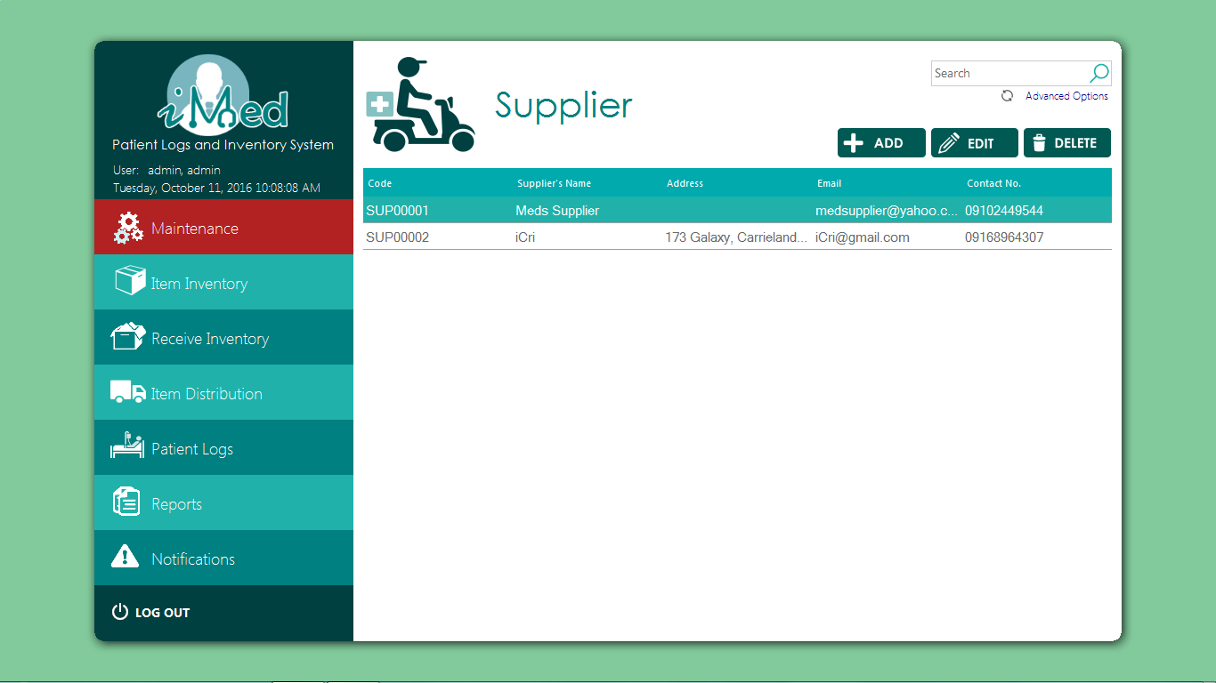

**Add Supplier Form**

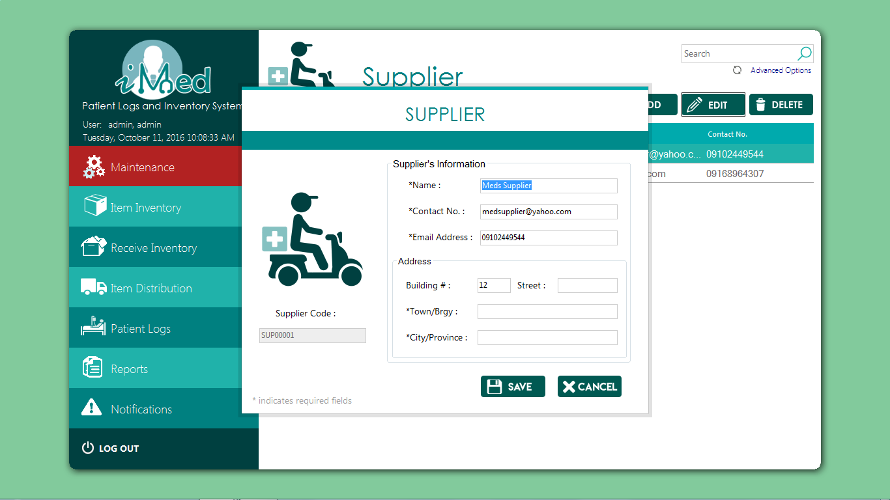

**Manufacturer Form**

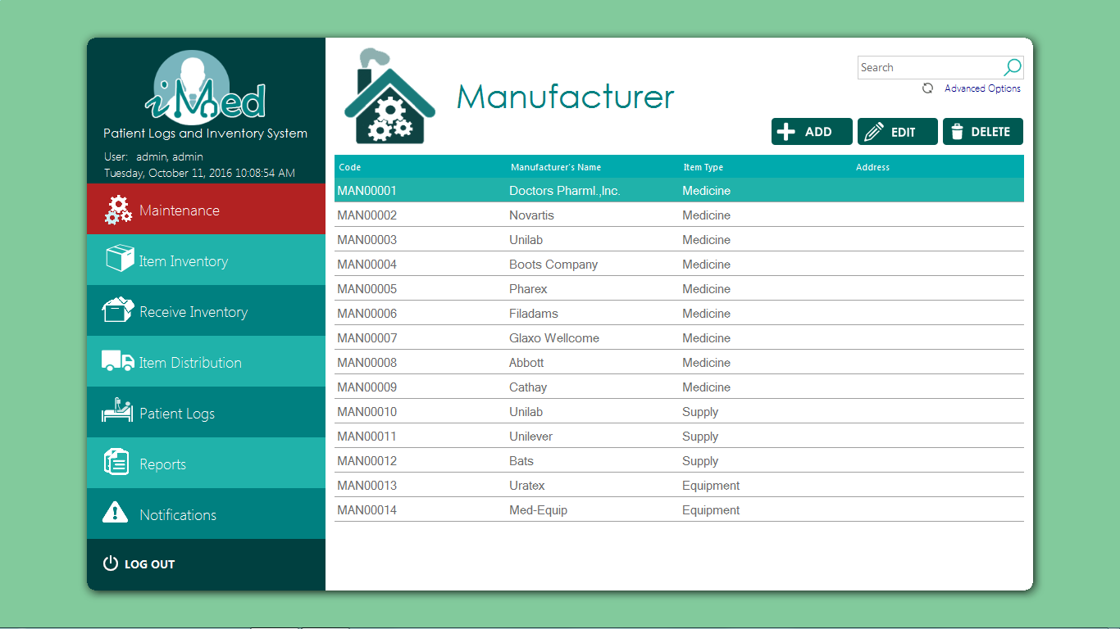

**Add Manufacturer Form**

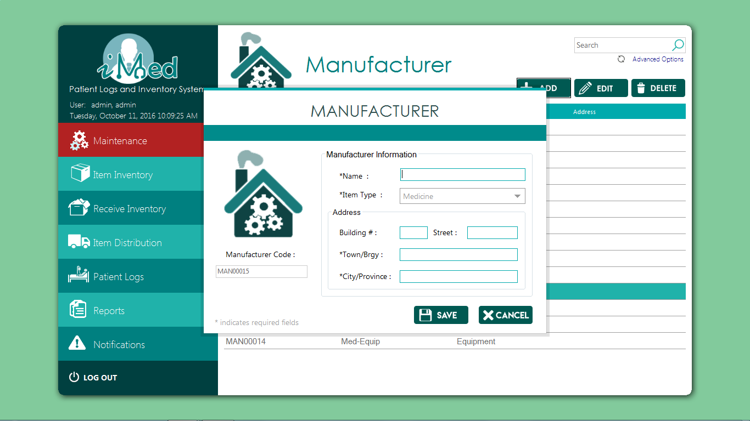

**Branches Form**

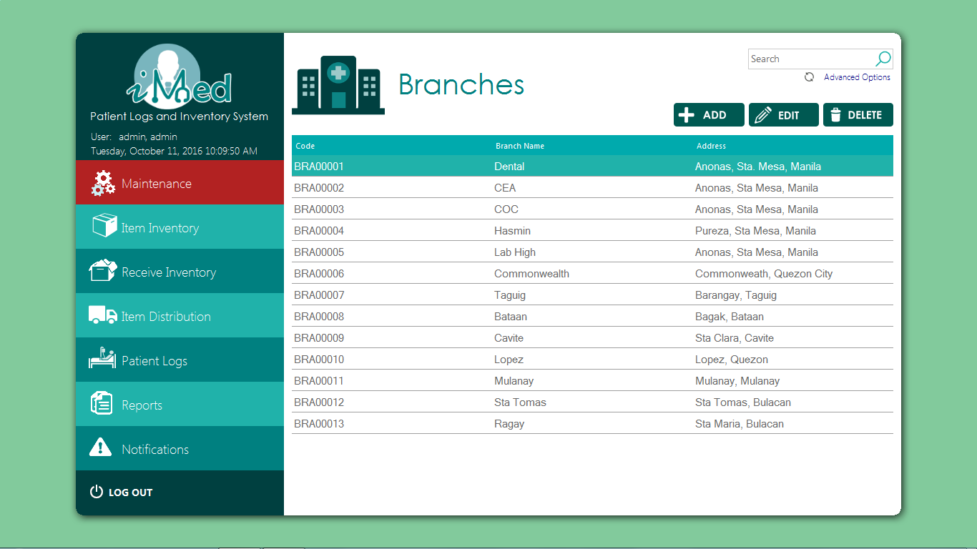

**Add Branches Form**

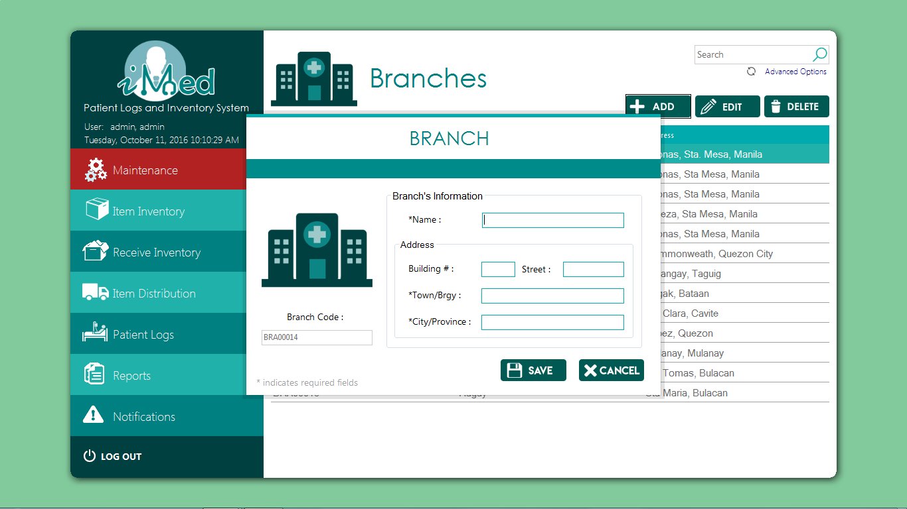

**College and Courses Form**

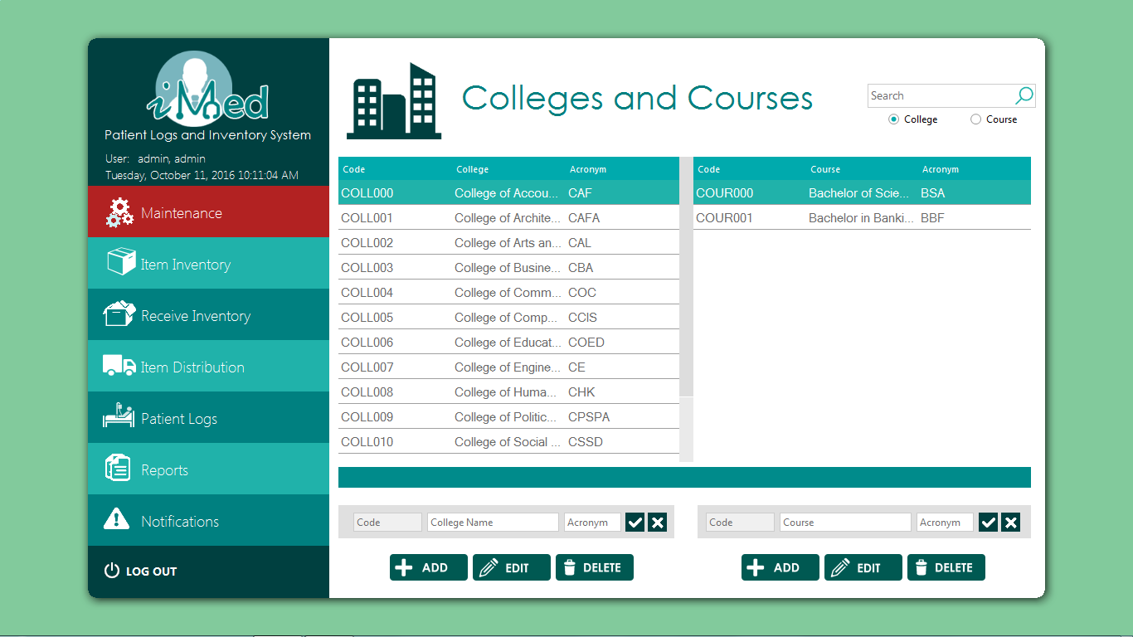

**Departments Form**

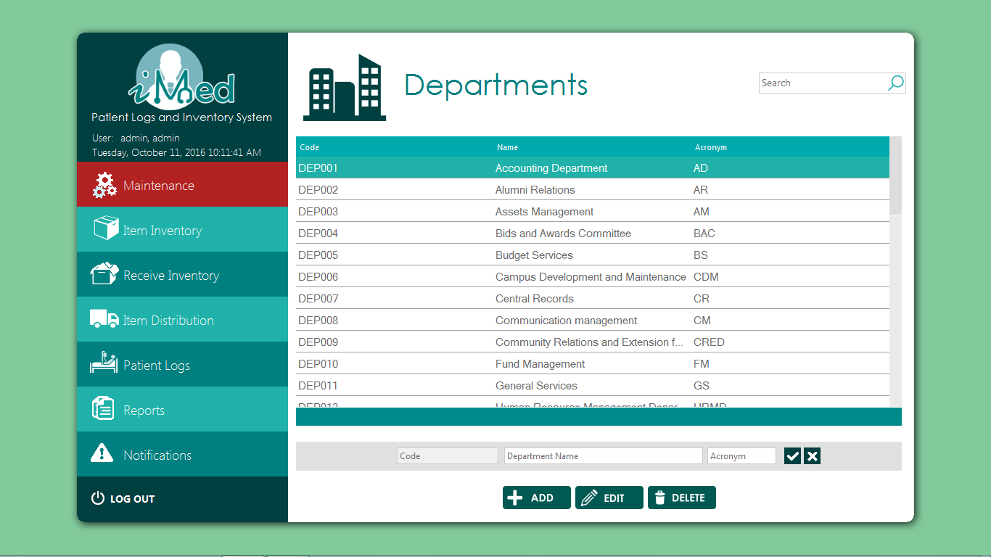

**Item Inventory**

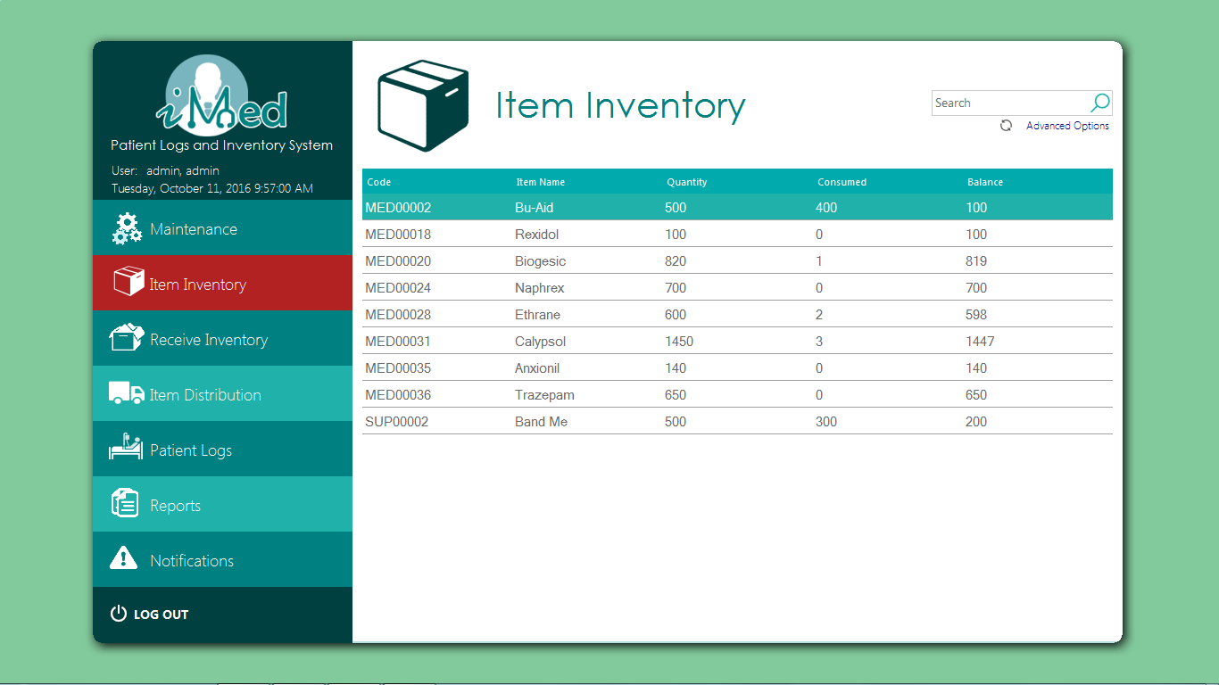

**Receive Inventory**

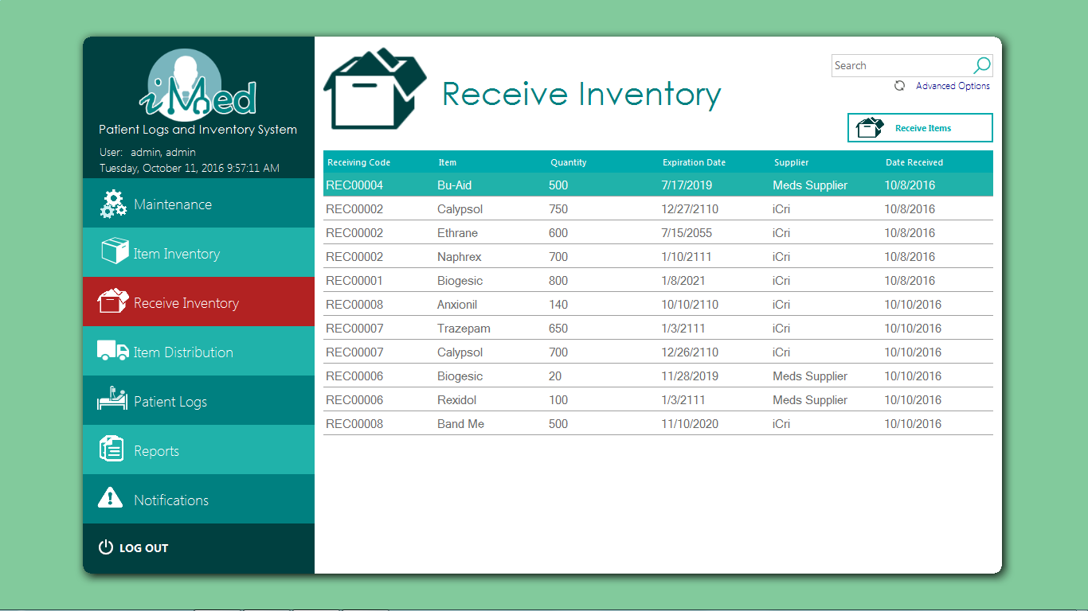

**Receive Items Form**

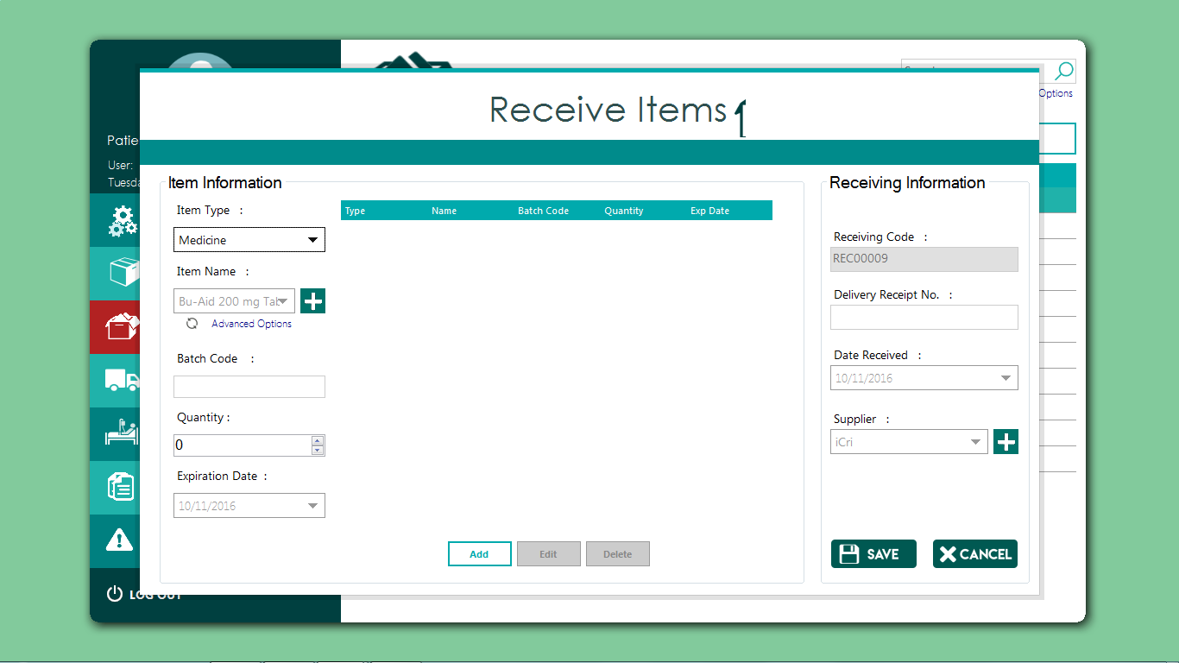

**Item Distribution Form**

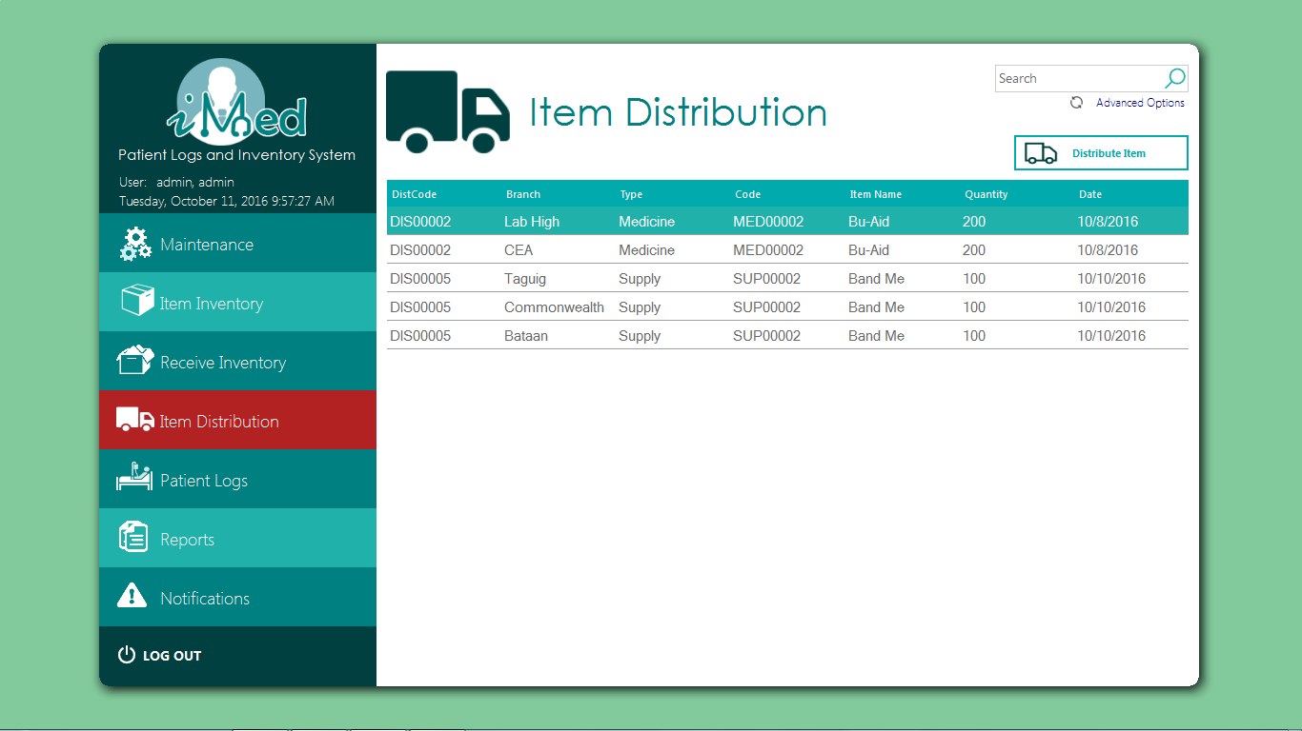

**Add Item to Distribute From**

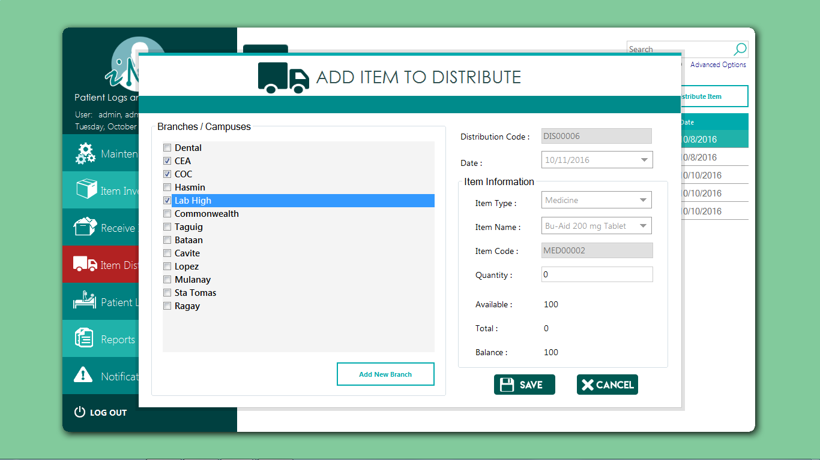

**Patient Logs Form**

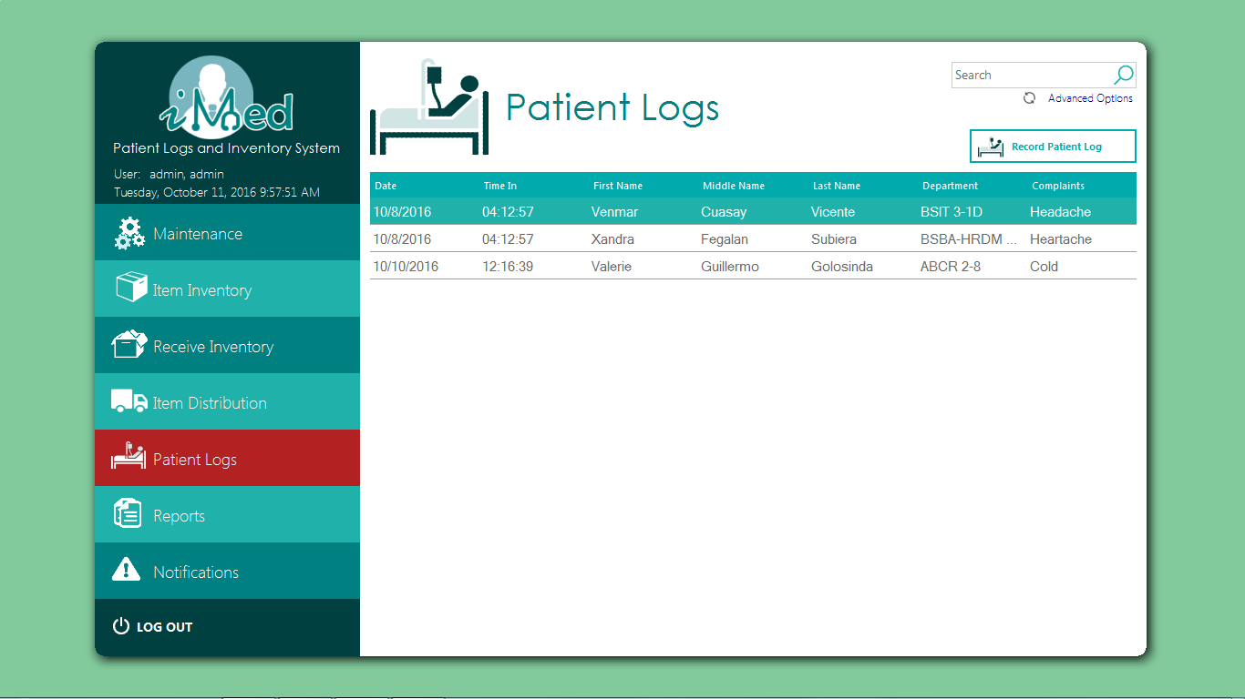

**Add Patient Logs Form**

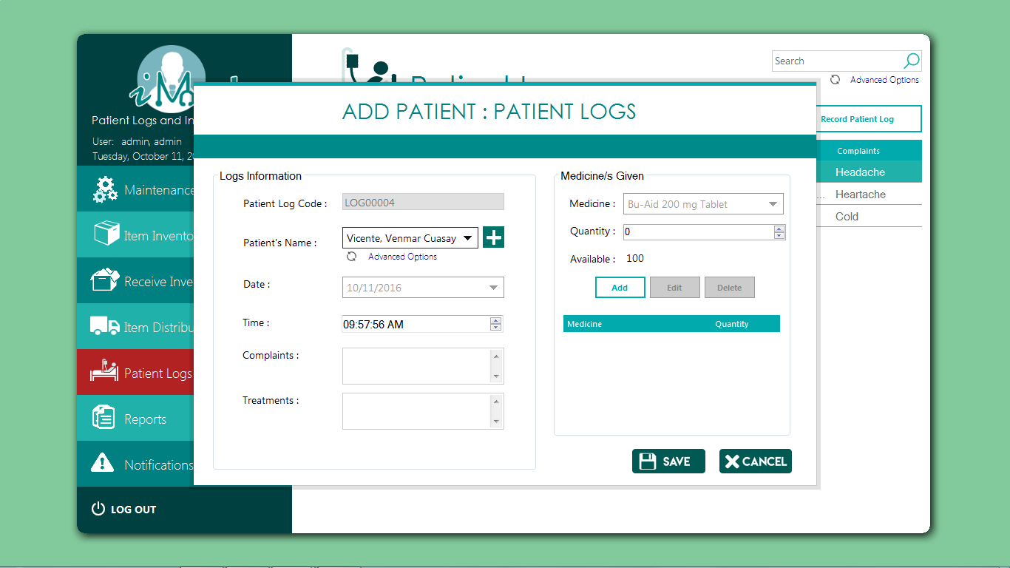

**Stock Card Report Form**

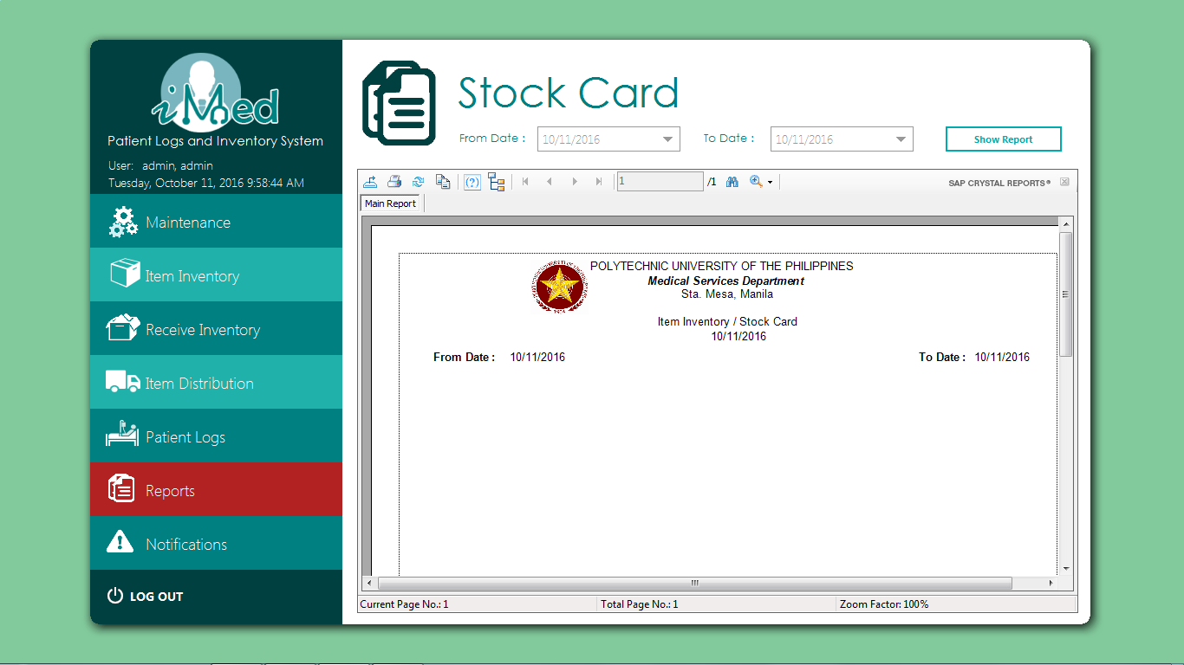

**Daily Treatment Records Form**

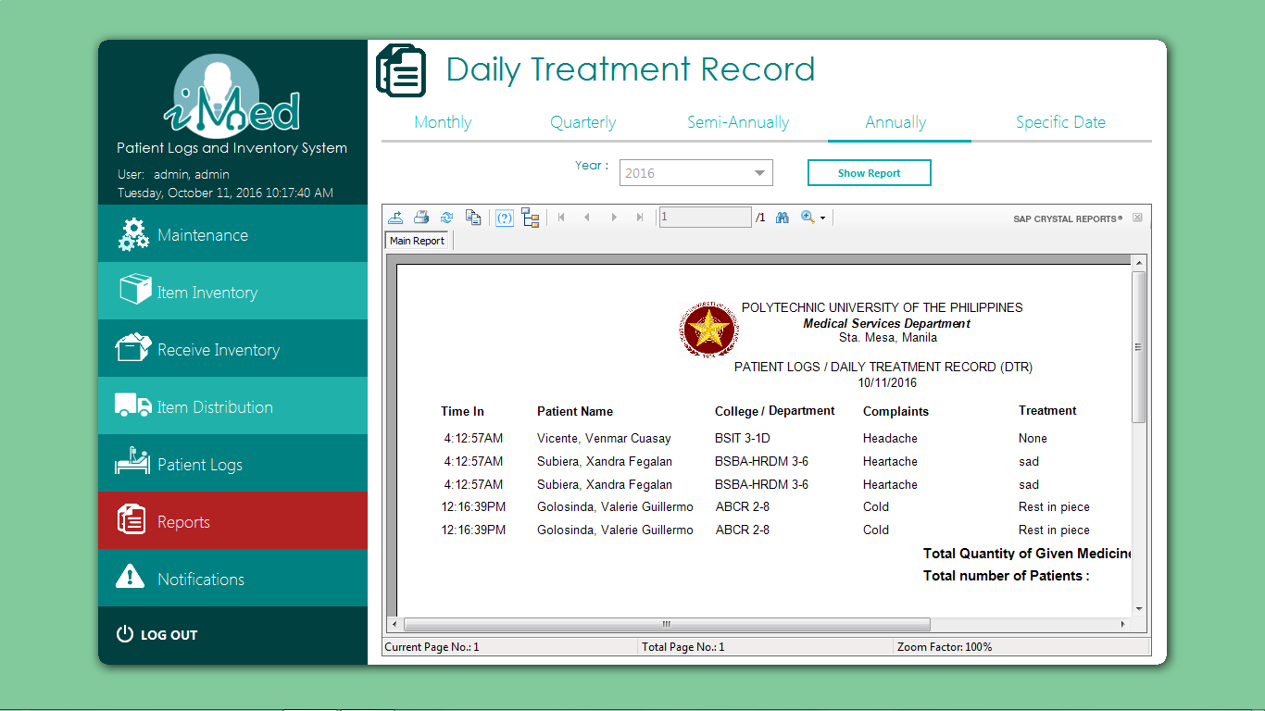

**Receive Item Report form**

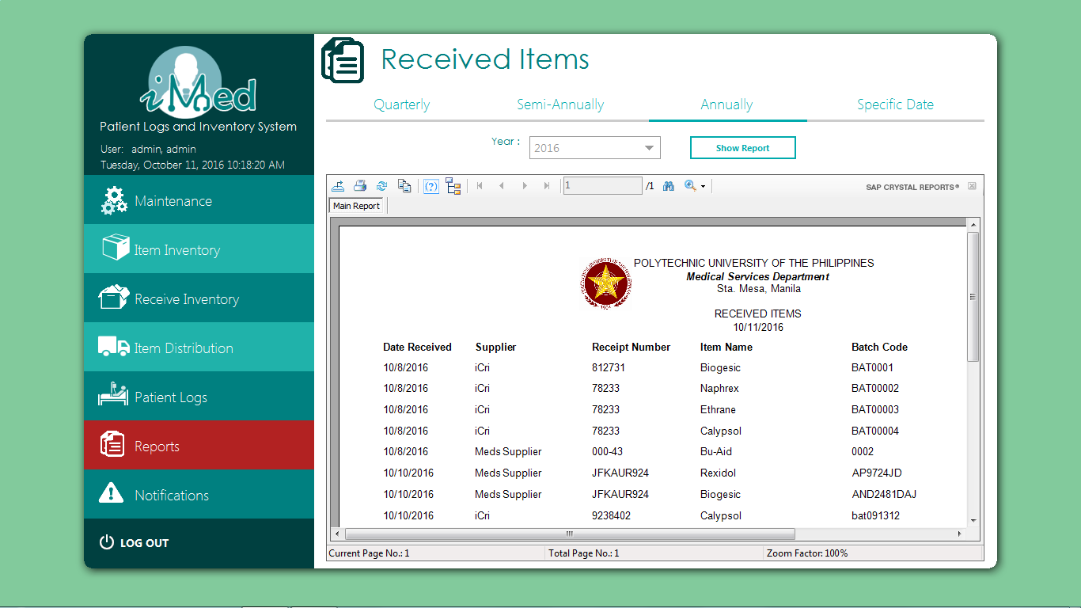

**Item Distribution Report Form**

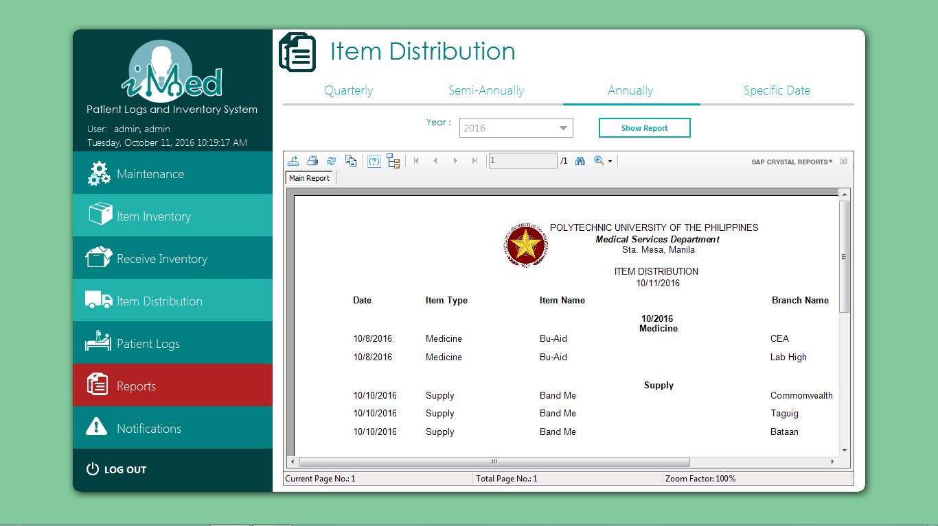

**List of Items Report Form**

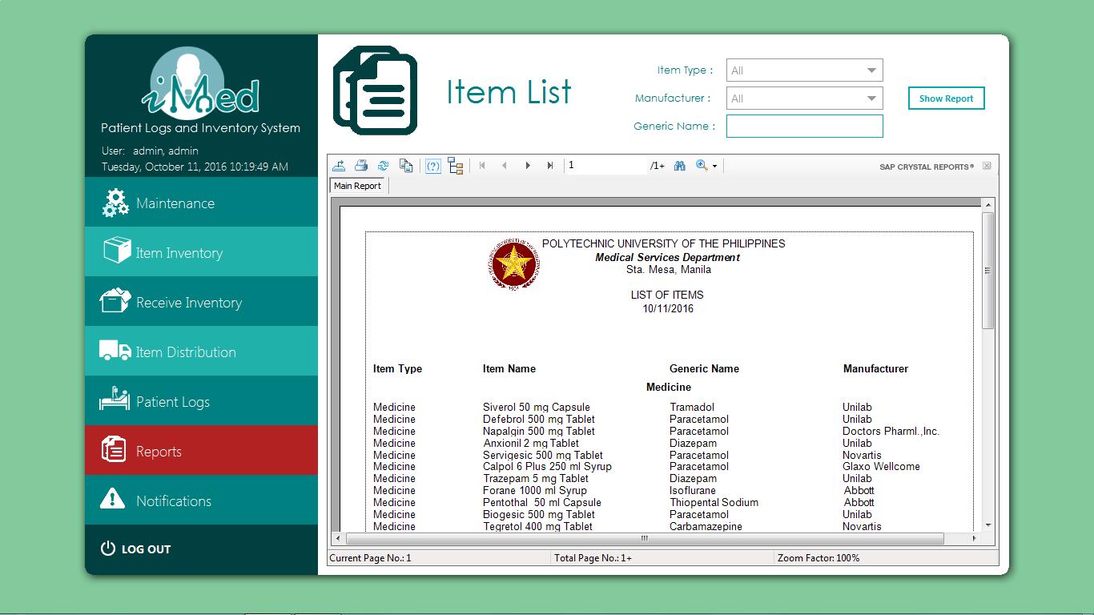

**Notifications Form**

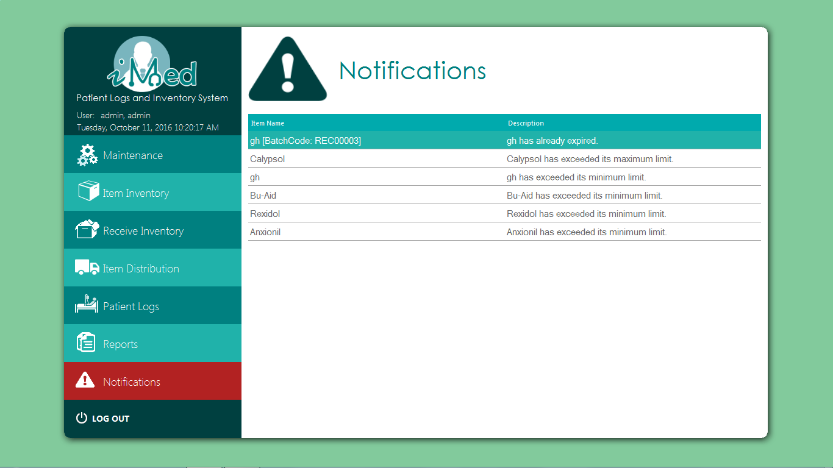

**4.3. Entity Relationship Diagram**

Static

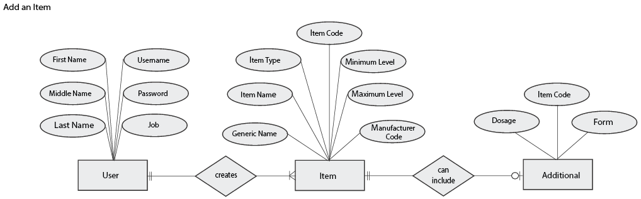

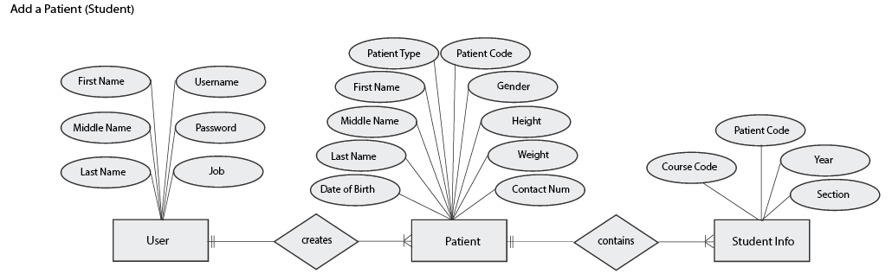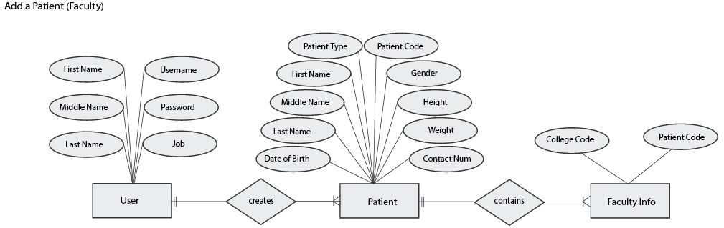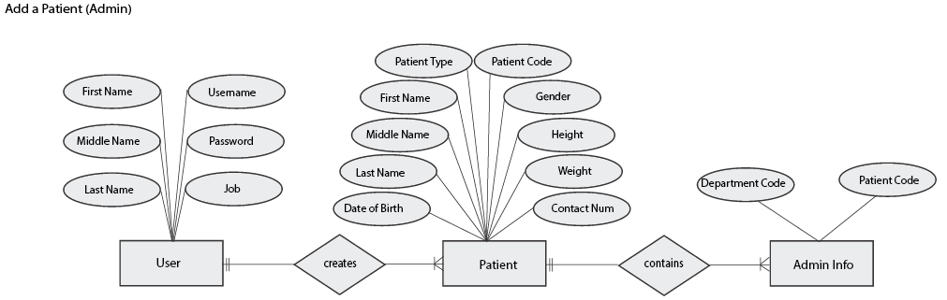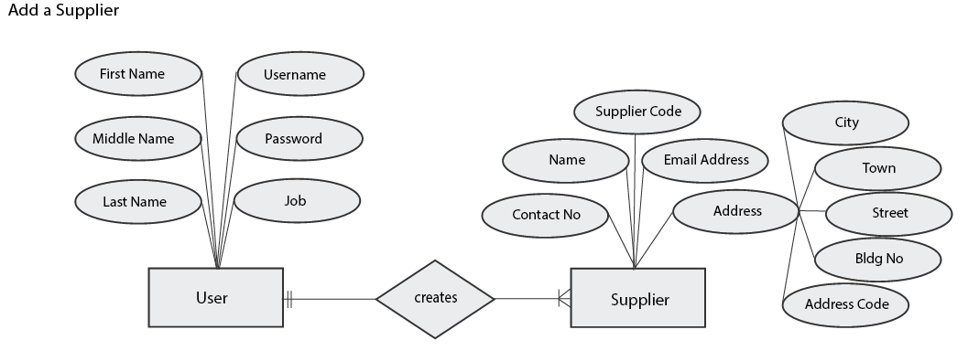

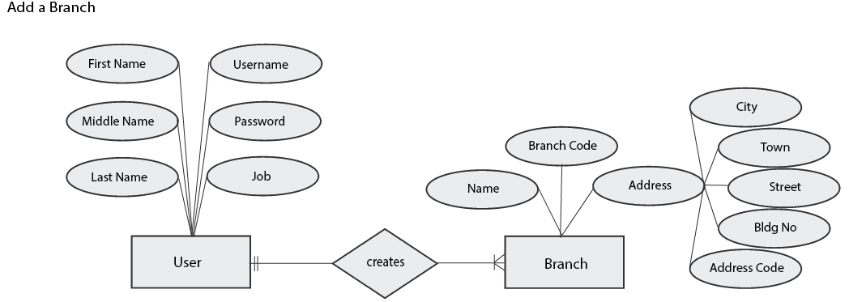

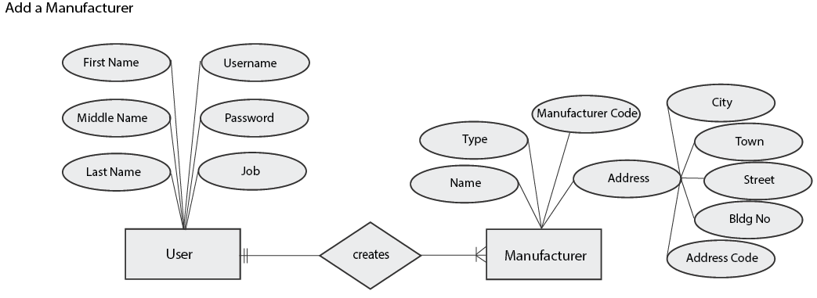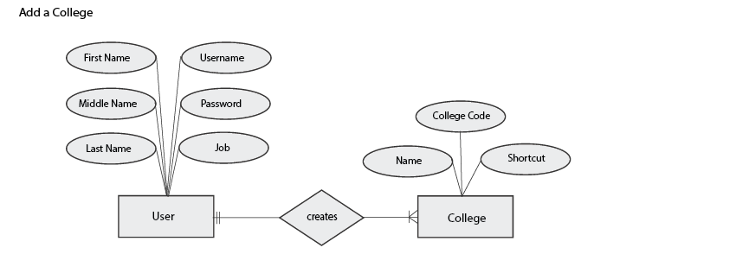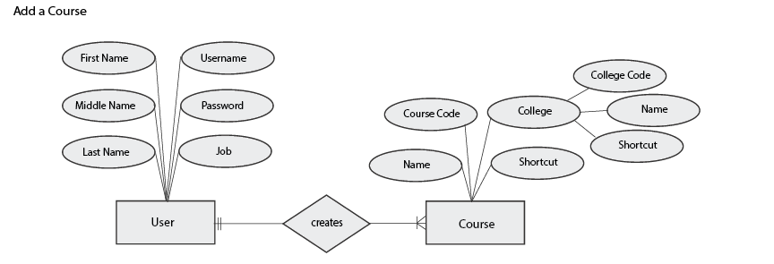

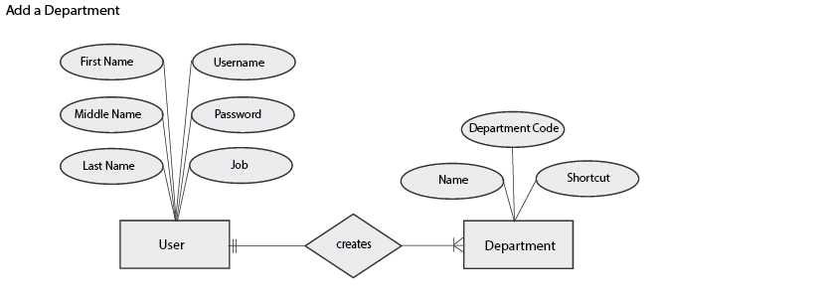

Transaction

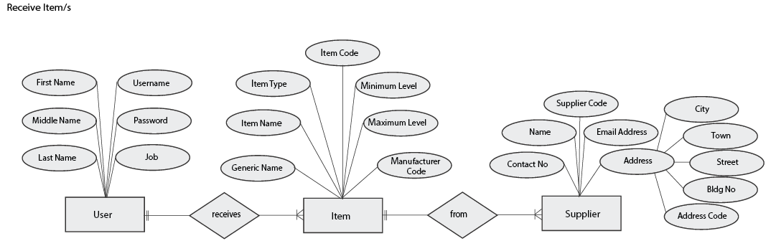

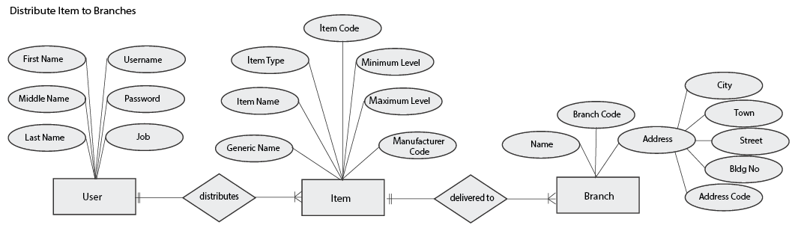

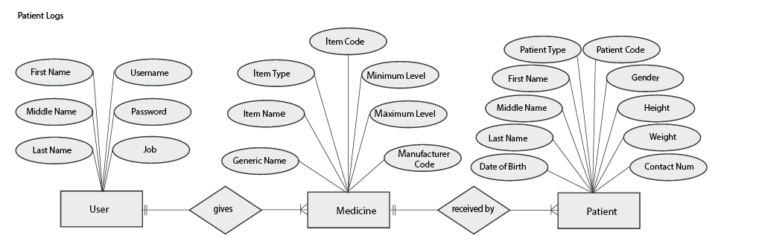

Reports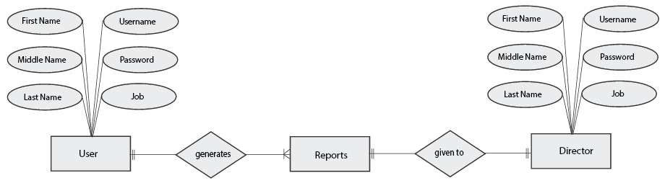

**4.4 Conceptual Data Model**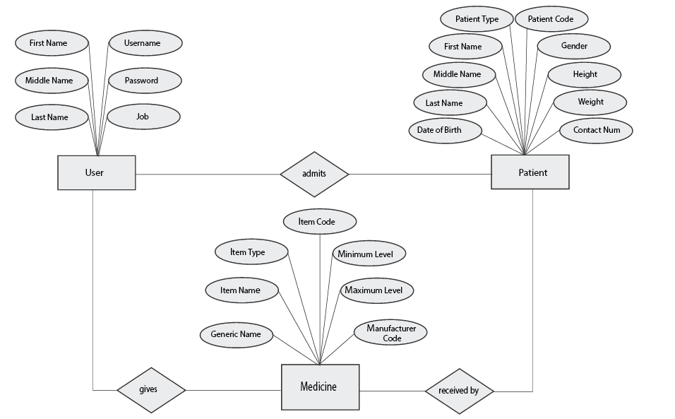

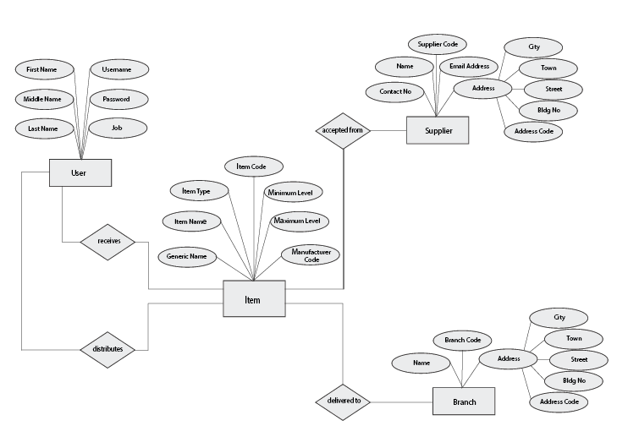

**4.5 Normalization**

**Receiving of Items**

|  |  |  |  |  |
| --- | --- | --- | --- | --- |
| **UNNORMALIZED FORM** |  | **1ST NORMAL FORM** |  | **2ND NORMAL FORM** |
|  |  |  |  |  |
| strItemCode |  | strItemCode |  | strItemCode |
| strItemName |  | strItemName |  | strItemName |
| strItemGeneric |  | strItemGeneric |  | strItemGeneric |
| intItemMin |  | intItemMin |  | intItemMin |
| intItemMax |  | intItemMax |  | intItemMax |
| intItemType |  | intItemType |  | intItemType |
| boolItemDeleted |  | boolItemDeleted |  | boolItemDeleted |
| dtmItemDeleted |  | dtmItemDeleted |  | dtmItemDeleted |
| strItemDeleted |  | strItemDeleted |  | strItemDeleted |
| dtmItemAdded |  | dtmItemAdded |  | dtmItemAdded |
| strItemAdded |  | strItemAdded |  | strItemAdded |
| strAddiItemCode |  | strAddiItemCode |  |  |
| strAddiDosage |  | strAddiDosage |  | strAddiItemCode |
| strAddiForm |  | strAddiForm |  | strAddiDosage |
| strManuCode |  |  |  | strAddiForm |
| strManuName |  | strManuCode |  |  |
| intManuType |  | strManuName |  | strManuCode |
| strManuAddress |  | intManuType |  | strManuName |
| boolManuDeleted |  | strManuAddrCode |  | intManuType |
| dtmManuDeleted |  | boolManuDeleted |  | strManuAddrCode |
| strManuDeleted |  | dtmManuDeleted |  | boolManuDeleted |
| dtmManuAdded |  | strManuDeleted |  | dtmManuDeleted |
| strManuAdded |  | dtmManuAdded |  | strManuDeleted |
| strRecHCode |  | strManuAdded |  | dtmManuAdded |
| strRecHDeliveryReceipt |  |  |  | strManuAdded |
| strRecHSuppCode |  | strRecHCode |  |  |
| datRecHDateReceived |  | strRecHDeliveryReceipt |  | strRecHCode |
| dtmRecHAdded |  | strRecHSuppCode |  | strRecHDeliveryReceipt |
| strRecHAdded |  | datRecHDateReceived |  | strRecHSuppCode |
| strRecDRecHCode |  | dtmRecHAdded |  | datRecHDateReceived |
| strRecDItemCode |  | strRecHAdded |  | dtmRecHAdded |
| strRecDBatchCode |  | strRecDRecHCode |  | strRecHAdded |
| intRecDQty |  | strRecDItemCode |  |  |
| datRecDExpDate |  | strRecDBatchCode |  | strRecDRecHCode |
| strSuppCode |  | intRecDQty |  | strRecDItemCode |
| strSuppName |  | datRecDExpDate |  | strRecDBatchCode |
| strSuppAddress |  | strSuppCode |  | intRecDQty |
| strSuppContactNo |  | strSuppName |  | datRecDExpDate |
| strSuppEmail |  | strSuppAddrCode |  |  |
| boolSuppDeleted |  | strSuppContactNo |  | strSuppCode |
| dtmSuppDeleted |  | strSuppEmail |  | strSuppName |
| strSuppDeleted |  | boolSuppDeleted |  | strSuppAddrCode |
| dtmSuppAdded |  | dtmSuppDeleted |  | strSuppContactNo |
| strSuppAdded |  | strSuppDeleted |  | strSuppEmail |
|  |  | dtmSuppAdded |  | boolSuppDeleted |
|  |  | strSuppAdded |  | dtmSuppDeleted |
|  |  |  |  | strSuppDeleted |
|  |  | strAddrCode |  | dtmSuppAdded |
|  |  | strAddrNum |  | strSuppAdded |
|  |  | strAddrStreet |  |  |
|  |  | strAddrTown |  | strAddrCode |
|  |  | strAddrCity |  | strAddrNum |
|  |  | dtmAddrAdded |  | strAddrStreet |
|  |  | strAddrAdded |  | strAddrTown |
|  |  |  |  | strAddrCity |
|  |  |  |  | dtmAddrAdded |
|  |  |  |  | strAddrAdded |

**Distribution of Items**

|  |  |  |  |  |
| --- | --- | --- | --- | --- |
| **UNNORMALIZED FORM** |  | **1ST NORMAL FORM** |  | **2ND NORMAL FORM** |
|  |  |  |  |  |
| strItemCode |  | strItemCode |  | strItemCode |
| strItemName |  | strItemName |  | strItemName |
| strItemGeneric |  | strItemGeneric |  | strItemGeneric |
| intItemMin |  | intItemMin |  | intItemMin |
| intItemMax |  | intItemMax |  | intItemMax |
| intItemType |  | intItemType |  | intItemType |
| boolItemDeleted |  | boolItemDeleted |  | boolItemDeleted |
| dtmItemDeleted |  | dtmItemDeleted |  | dtmItemDeleted |
| strItemDeleted |  | strItemDeleted |  | strItemDeleted |
| dtmItemAdded |  | dtmItemAdded |  | dtmItemAdded |
| strItemAdded |  | strItemAdded |  | strItemAdded |
| strAddiItemCode |  | strAddiItemCode |  |  |
| strAddiDosage |  | strAddiDosage |  | strAddiItemCode |
| strAddiForm |  | strAddiForm |  | strAddiDosage |
| strManuCode |  |  |  | strAddiForm |
| strManuName |  | strManuCode |  |  |
| intManuType |  | strManuName |  | strManuCode |
| strManuAddress |  | intManuType |  | strManuName |
| boolManuDeleted |  | strManuAddrCode |  | intManuType |
| dtmManuDeleted |  | boolManuDeleted |  | strManuAddrCode |
| strManuDeleted |  | dtmManuDeleted |  | boolManuDeleted |
| dtmManuAdded |  | strManuDeleted |  | dtmManuDeleted |
| strManuAdded |  | dtmManuAdded |  | strManuDeleted |
| strBranCode |  | strManuAdded |  | dtmManuAdded |
| strBranDesc |  |  |  | strManuAdded |
| strBranAddress |  | strBranCode |  |  |
| boolBranDeleted |  | strBranDesc |  | strBranCode |
| dtmBranDeleted |  | strBranAddrCode |  | strBranDesc |
| strBranDeleted |  | boolBranDeleted |  | strBranAddrCode |
| dtmBranAdded |  | dtmBranDeleted |  | boolBranDeleted |
| strBranAdded |  | strBranDeleted |  | dtmBranDeleted |
| strDisDDisHCode |  | dtmBranAdded |  | strBranDeleted |
| strDisDBranCode |  | strBranAdded |  | dtmBranAdded |
| strDisHCode |  | strDisDDisHCode |  | strBranAdded |
| datDisHDate |  | strDisDBranCode |  |  |
| strDisHItemCode |  | strDisHCode |  | strDisDDisHCode |
| intDisHQty |  | datDisHDate |  | strDisDBranCode |
| dtmDisHAdded |  | strDisHItemCode |  |  |
| strDisHAdded |  | intDisHQty |  | strDisHCode |
|  |  | dtmDisHAdded |  | datDisHDate |
|  |  | strDisHAdded |  | strDisHItemCode |
|  |  |  |  | intDisHQty |
|  |  | strAddrCode |  | dtmDisHAdded |
|  |  | strAddrNum |  | strDisHAdded |
|  |  | strAddrStreet |  |  |
|  |  | strAddrTown |  | strAddrCode |
|  |  | strAddrCity |  | strAddrNum |
|  |  | dtmAddrAdded |  | strAddrStreet |
|  |  | strAddrAdded |  | strAddrTown |
|  |  |  |  | strAddrCity |
|  |  |  |  | dtmAddrAdded |
|  |  |  |  | strAddrAdded |

**Patient Logs**

|  |  |  |  |  |
| --- | --- | --- | --- | --- |
| **UNNORMALIZED FORM** |  | **1ST NORMAL FORM** |  | **2ND NORMAL FORM** |
|  |  |  |  |  |
| strItemCode |  | strItemCode |  | strItemCode |
| strItemName |  | strItemName |  | strItemName |
| strItemGeneric |  | strItemGeneric |  | strItemGeneric |
| intItemMin |  | intItemMin |  | intItemMin |
| intItemMax |  | intItemMax |  | intItemMax |
| intItemType |  | intItemType |  | intItemType |
| boolItemDeleted |  | boolItemDeleted |  | boolItemDeleted |
| dtmItemDeleted |  | dtmItemDeleted |  | dtmItemDeleted |
| strItemDeleted |  | strItemDeleted |  | strItemDeleted |
| dtmItemAdded |  | dtmItemAdded |  | dtmItemAdded |
| strItemAdded |  | strItemAdded |  | strItemAdded |
| strAddiItemCode |  | strAddiItemCode |  |  |
| strAddiDosage |  | strAddiDosage |  | strAddiItemCode |
| strAddiForm |  | strAddiForm |  | strAddiDosage |
| strManuCode |  |  |  | strAddiForm |
| strManuName |  | strManuCode |  |  |
| intManuType |  | strManuName |  | strManuCode |
| strManuAddress |  | intManuType |  | strManuName |
| boolManuDeleted |  | strManuAddrCode |  | intManuType |
| dtmManuDeleted |  | boolManuDeleted |  | strManuAddrCode |
| strManuDeleted |  | dtmManuDeleted |  | boolManuDeleted |
| dtmManuAdded |  | strManuDeleted |  | dtmManuDeleted |
| strManuAdded |  | dtmManuAdded |  | strManuDeleted |
| strPatiCode |  | strManuAdded |  | dtmManuAdded |
| intPatiType |  |  |  | strManuAdded |
| strPatiName |  | strAddrCode |  |  |
| datPatiDOB |  | strAddrNum |  | strAddrCode |
| intPatiGender |  | strAddrStreet |  | strAddrNum |
| fltPatiHeight |  | strAddrTown |  | strAddrStreet |
| fltPatiWeight |  | strAddrCity |  | strAddrTown |
| strPatiContact |  | dtmAddrAdded |  | strAddrCity |
| boolPatiDeleted |  | strAddrAdded |  | dtmAddrAdded |
| dtmPatiDeleted |  |  |  | strAddrAdded |
| strPatiDeleted |  | strPatiCode |  |  |
| dtmPatiAdded |  | intPatiType |  | strPatiCode |
| strPatiAdded |  | strPatiLastName |  | intPatiType |
| strFacIPatiCode |  | strPatiFirstName |  | strPatiLastName |
| strFacICollCode |  | strPatiMiddleName |  | strPatiFirstName |
| dtmFacIAdded |  | datPatiDOB |  | strPatiMiddleName |
| strCollCode |  | intPatiGender |  | datPatiDOB |
| strCollName |  | fltPatiHeight |  | intPatiGender |
| strCollShort |  | fltPatiWeight |  | fltPatiHeight |
| boolCollDeleted |  | strPatiContact |  | fltPatiWeight |
| dtmCollDeleted |  | boolPatiDeleted |  | strPatiContact |
| strCollDeleted |  | dtmPatiDeleted |  | boolPatiDeleted |
| dtmCollAdded |  | strPatiDeleted |  | dtmPatiDeleted |
| strCollAdded |  | dtmPatiAdded |  | strPatiDeleted |
| strStuIPatiCode |  | strPatiAdded |  | dtmPatiAdded |
| strStuICourCode |  | strFacIPatiCode |  | strPatiAdded |
| dtmStuIAdded |  | strFacICollCode |  |  |
| strStuIYear |  | dtmFacIAdded |  | strFacIPatiCode |
| strStuISection |  | strStuIPatiCode |  | strFacICollCode |
| strCourCode |  | strStuICourCode |  | dtmFacIAdded |
| strCourName |  | dtmStuIAdded |  |  |
| strCourCollCode |  | strStuIYear |  | strStuIPatiCode |
| strCourShort |  | strStuISection |  | strStuICourCode |
| boolCourDeleted |  | strAdmIPatiCode |  | dtmStuIAdded |
| dtmCourDeleted |  | strAdmIDeptCode |  | strStuIYear |
| strCourDeleted |  | dtmAdmIAdded |  | strStuISection |
| dtmCourAdded |  |  |  |  |
| strCourAdded |  | strCollCode |  | strAdmIPatiCode |
| strAdmIPatiCode |  | strCollName |  | strAdmIDeptCode |
| strAdmIDeptCode |  | strCollShort |  | dtmAdmIAdded |
| dtmAdmIAdded |  | boolCollDeleted |  |  |
| strDeptCode |  | dtmCollDeleted |  | strCollCode |
| strDeptName |  | strCollDeleted |  | strCollName |
| strDeptShort |  | dtmCollAdded |  | strCollShort |
| boolDeptDeleted |  | strCollAdded |  | boolCollDeleted |
| dtmDeptDeleted |  |  |  | dtmCollDeleted |
| strDeptDeleted |  | strCourCode |  | strCollDeleted |
| dtmDeptAdded |  | strCourName |  | dtmCollAdded |
| strDeptAdded |  | strCourCollCode |  | strCollAdded |
| strLogHCode |  | strCourShort |  |  |
| datLogHDatetime |  | boolCourDeleted |  | strCourCode |
| strLogHPatiCode |  | dtmCourDeleted |  | strCourName |
| strLogsComplaints |  | strCourDeleted |  | strCourCollCode |
| strLogHTreatment |  | dtmCourAdded |  | strCourShort |
| dtmLogHAdded |  | strCourAdded |  | boolCourDeleted |
| strLogHAdded |  |  |  | dtmCourDeleted |
| strLogDLogHCode |  | strDeptCode |  | strCourDeleted |
| strLogDItemCode |  | strDeptName |  | dtmCourAdded |
| intLogDQty |  | strDeptShort |  | strCourAdded |
|  |  | boolDeptDeleted |  |  |
|  |  | dtmDeptDeleted |  | strDeptCode |
|  |  | strDeptDeleted |  | strDeptName |
|  |  | dtmDeptAdded |  | strDeptShort |
|  |  | strDeptAdded |  | boolDeptDeleted |
|  |  |  |  | dtmDeptDeleted |
|  |  | strLogHCode |  | strDeptDeleted |
|  |  | datLogHDatetime |  | dtmDeptAdded |
|  |  | strLogHPatiCode |  | strDeptAdded |
|  |  | strLogsComplaints |  |  |
|  |  | strLogHTreatment |  | strLogHCode |
|  |  | dtmLogHAdded |  | datLogHDatetime |
|  |  | strLogHAdded |  | strLogHPatiCode |
|  |  | strLogDLogHCode |  | strLogsComplaints |
|  |  | strLogDItemCode |  | strLogHTreatment |
|  |  | intLogDQty |  | dtmLogHAdded |
|  |  |  |  | strLogHAdded |
|  |  |  |  |  |
|  |  |  |  | strLogDLogHCode |
|  |  |  |  | strLogDItemCode |
|  |  |  |  | intLogDQty |

**4.6 Relational Database Management System**

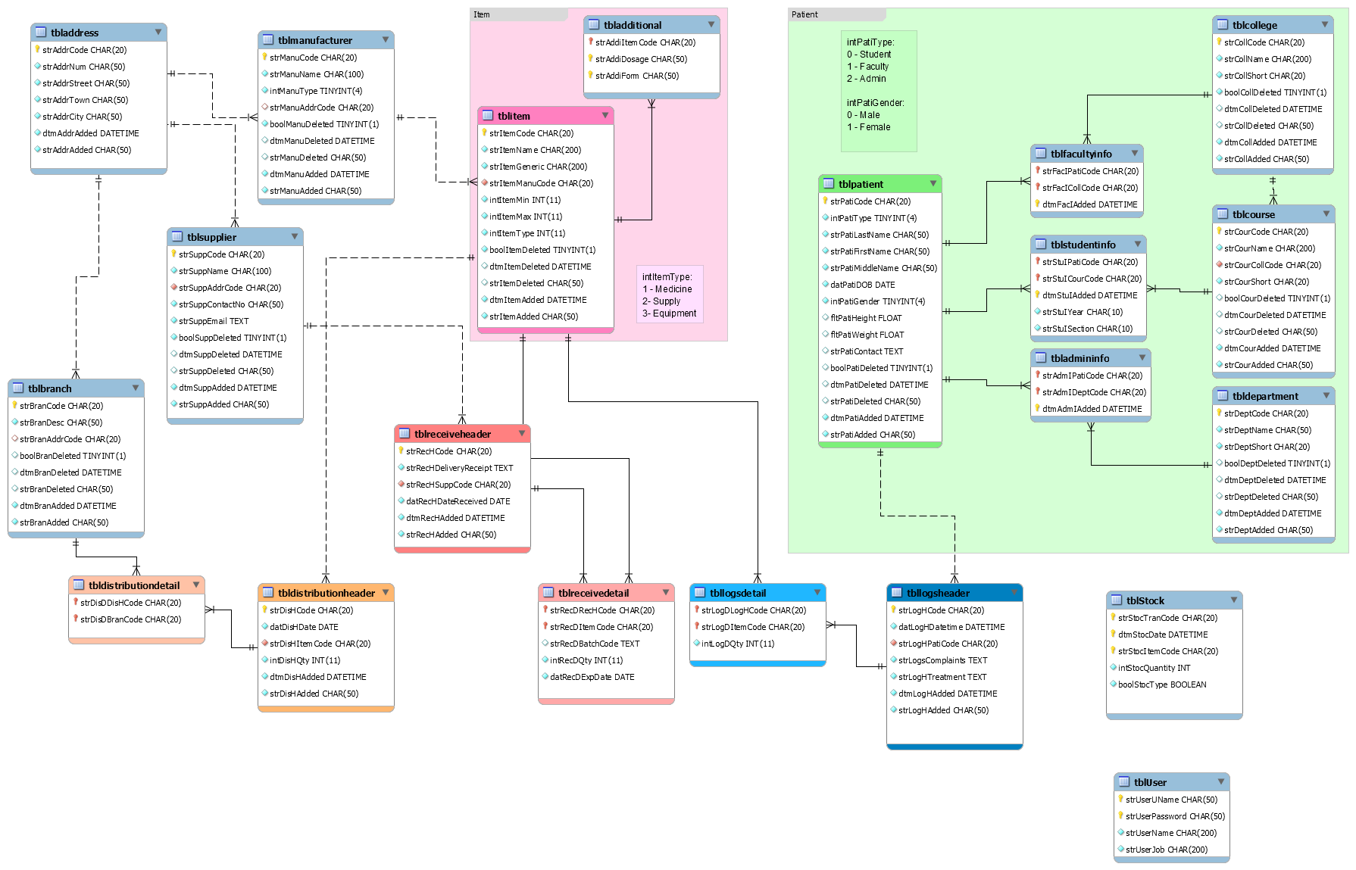

**4.7 Data Dictionary**

**Medicine Form**

|  |  |  |  |  |  |
| --- | --- | --- | --- | --- | --- |
| **FIELD NAME** | **FIELD TYPE** | **FIELD LENGTH** | **DECIMAL** | **FORMAT** | **DESC.** |
| Medicine Code | Alphanumeric | 20 | 0 | X(15) | Code of the medicine |
| Name | Alphanumeric | 200 | 0 | X(200) | Name of the medicine |
| Generic Name | Alphanumeric | 200 | 0 | X(200) | Generic name of the medicine |
| Dosage | Alphanumeric | 50 | 0 | X(50) | The dosage of the medicine |
| Form | Alphanumeric | 50 | 0 | X(50) | Combo box for choosing form of medicine. |
| Manufacturer | Alphanumeric | 100 | 0 | X(100) | Name of the manufacturer |
| Minimum | Numeric | 11 | 0 | 9 (11) | Minimum value |
| Maximum | Numeric | 11 | 0 | 9 (11) | Maximum value |

**Supply Form**

|  |  |  |  |  |  |
| --- | --- | --- | --- | --- | --- |
| **FIELD NAME** | **FIELD TYPE** | **FIELD LENGTH** | **DECIMAL** | **FORMAT** | **DESC.** |
| Supply Code | Alphanumeric | 20 | 0 | X(15) | Code of the supply |
| Name | Alphanumeric | 200 | 0 | X(200) | Name of the supply |
| Generic Name | Alphanumeric | 200 | 0 | X(200) | Generic name of the supply |
| Dosage | Alphanumeric | 50 | 0 | X(50) | The dosage of the supply |
| Form | Alphanumeric | 50 | 0 | X50) | Combo box for choosing form of supply |
| Manufacturer | Alphanumeric | 100 | 0 | X (100) | Name of the manufacturer |
| Minimum | Numeric | 11 | 0 | 9(11) | Minimum value |
| Maximum | Numeric | 11 | 0 | 9(11) | Maximum value |

**Equipment Form**

|  |  |  |  |  |  |
| --- | --- | --- | --- | --- | --- |
| **FIELD NAME** | **FIELD TYPE** | **FIELD LENGTH** | **DECIMAL** | **FORMAT** | **DESC.** |
| Equipment Code | Alphanumeric | 20 | 0 | X(15) | Code of the equipment |
| Name | Alphanumeric | 200 | 0 | X(200) | Name of the equipment |
| Generic Name | Alphanumeric | 200 | 0 | X(200) | Generic name of the equipment |
| Manufacturer | Alphanumeric | 100 | 0 | X(100) | Name of the manufacturer |
| Minimum | Numeric | 11 | 0 | I9 (11) | Minimum value |
| Maximum | Numeric | 11 | 0 | 9 (11) | Maximum value |

**Student Form**

|  |  |  |  |  |  |
| --- | --- | --- | --- | --- | --- |
| **FIELD NAME** | **FIELD TYPE** | **FIELD LENGTH** | **DECIMAL** | **FORMAT** | **DESC.** |
| Patient Code | Alphanumeric | 20 | 0 | X(20) | **Code of the patient** |
| Patient Type | Alphabet | 4 | 0 | TINYINT  (4) | Type of the patient |
| First Name | Alphanumeric | 50 | 0 | X(50) | First name of the patient |
| Middle Name | Alphanumeric | 50 | 0 | X(50) | Middle name of the patient |
| Last Name | Alphanumeric | 50 | 0 | X(50) | Last name of the patient |
| Birth Day | Numeric | - | 0 | MM/DD/YYYY | Birthday of the patient |
| College | Alphanumeric | 200 | 0 | X(200) | College of the patient |
| Course | Alphanumeric | 200 | 0 | X (200) | Course of the patient |
| Year | Alphanumeric | 10 | 0 | X (10) | Year of the patient |
| Section | Numeric | 10 | 0 | X (10) | Section of the patient |
| Gender | Numeric | 4 | 0 | TINYINT (4) | Gender of the patient |
| Height | Numeric | 10 | 4 | 999.99 | Height of the patient |
| Weight | Numeric | 10 | 4 | 999.99 | Weight of the patient |
| Contact No | Alphanumeric | 20 | 0 | TEXT | Contact number of the patient |

**Supplier Form**

|  |  |  |  |  |  |
| --- | --- | --- | --- | --- | --- |
| **FIELD NAME** | **FIELD TYPE** | **FIELD LENGTH** | **DECIMAL** | **FORMAT** | **DESC.** |
| Supplier Code | Alphanumeric | 20 | 0 | X(20) | Code of the supplier |
| Name | Alphanumeric | 100 | 0 | X (100) | Name of the supplier |
| Contact No. | Alphanumeric | 50 | 0 | X(50) | Contact No. of the supplier |
| E-mail Address | Alphanumeric | - | 0 | TEXT | E-mail Address of the supplier |
| Building # | Alphanumeric | 50 | 0 | X (50) | Building # of the supplier |
| Street | Alphanumeric | 50 | 0 | X(50) | Street of the supplier |
| Town/Brgy | Alphanumeric | 50 | 0 | X(50) | Town/Brgy of the supplier |
| City/Province | Alphanumeric | 50 | 0 | X(50) | City/Province of the supplier |

**Manufacturer Form**

|  |  |  |  |  |  |
| --- | --- | --- | --- | --- | --- |
| **FIELD NAME** | **FIELD TYPE** | **FIELD LENGTH** | **DECIMAL** | **FORMAT** | **DESC.** |
| Manufacturer Code | Alphanumeric | 20 | 0 | X(20) | Code of the manufacturer |
| Name | Alphanumeric | 100 | 0 | X (100) | Name of the manufacturer |
| Item Type | Alphanumeric | 4 | 0 | TINYINT (4) | Item Type of the manufacturer |
| Building # | Alphanumeric | 50 | 0 | X (50) | Building # of the manufacturer |
| Street | Alphanumeric | 50 | 0 | X(50) | Street of the manufacturer |
| Town/Brgy | Alphanumeric | 50 | 0 | X(50) | Town/Brgy of the manufacturer |
| City/Province | Alphanumeric | 50 | 0 | X(50) | City/Province of the manufacturer |

**Branches Form**

|  |  |  |  |  |  |
| --- | --- | --- | --- | --- | --- |
| **FIELD NAME** | **FIELD TYPE** | **FIELD LENGTH** | **DECIMAL** | **FORMAT** | **DESC.** |
| Branch Code | Alphanumeric | 20 | 0 | X(20) | Code of the branch |
| Name | Alphanumeric | 100 | 0 | X (100) | Name of the branch |
| Building # | Alphanumeric | 50 | 0 | X (50) | Building # of the branch |
| Street | Alphanumeric | 50 | 0 | X(50) | Street of the branch |
| Town/Brgy | Alphanumeric | 50 | 0 | X(50) | Town/Brgy of the branch |
| City/Province | Alphanumeric | 50 | 0 | X(50) | City/Province of the branch |

**Item Distribution Form**

|  |  |  |  |  |  |
| --- | --- | --- | --- | --- | --- |
| **FIELD NAME** | **FIELD TYPE** | **FIELD LENGTH** | **DECIMAL** | **FORMAT** | **DESC.** |
| Distribute Code | Alphanumeric | 20 | 0 | X(20) | Code of the distribution |
| Item Type | Alphabet | 4 | 0 | TINYINT  (4) | Type of the item |
| Item Name | Alphanumeric | 100 | 0 | X (100) | Name of the item |
| Item Code | Alphanumeric | 20 | 0 | X(20) | Code of the item |
| UOM | Alphanumeric | 5 | 0 | 9(5) | UOM of the item |
| Quantity | Numeric | 5 | 0 | 9(5) | Quantity of the item |
| Available | Numeric | 5 | 0 | 9(5) | Number Available items |
| Total | Numeric | 5 | 0 | 9(5) | Total number of items |
| Balance | Numeric | 5 | 0 | 9(5) | Balance of the items |
| Date | Numeric | - | 0 | MM/DD/YYYY | Date |

**Receive Inventory Form**

|  |  |  |  |  |  |
| --- | --- | --- | --- | --- | --- |
| **FIELD NAME** | **FIELD TYPE** | **FIELD LENGTH** | **DECIMAL** | **FORMAT** | **DESC.** |
| Item Type | Alphabet | 4 | 0 | TINYINT  (4) | Item Type of the received items |
| Item Name | Alphanumeric | 100 | 0 | X (100) | Item Name of the received items |
| Batch Code | Alphanumeric | 20 | 0 | X(20) | Batch Code of the received items |
| Quantity | Numeric | 5 | 0 | 9(5) | Quantity of the received items |
| Unit | Numeric | 5 | 0 | 9(5) | Unit of the received items |
| Piece per box | Numeric | 5 | 0 | 9(5) | Piece per box of the received items |
| Expiration Date | Numeric | - | 0 | MM/DD/YYYY | Expiration Date of the received items |
| Receiving Code | Alphanumeric | 20 | 0 | X(20) | Receiving Code of the received items |
| Delivery Receipt No. | Alphanumeric | 50 | 0 | X(50) | Delivery Receipt No. of the received items |
| Date Received | Numeric | - | 0 | MM/DD/YYYY | Date Received |
| Supplier | Alphanumeric | 100 | 0 | X (100) | Supplier of the received items |

**Patient Log (DTR) Form**

|  |  |  |  |  |  |
| --- | --- | --- | --- | --- | --- |
| **FIELD NAME** | **FIELD TYPE** | **FIELD LENGTH** | **DECIMAL** | **FORMAT** | **DESC.** |
| Patient Log Code | Alphanumeric | 20 | 0 | X(20) | Code for patient’s log |
| Patient’s Name | Alphanumeric | 100 | 0 | X (100) | Name of the patient |
| Time IN | Numeric | - | 0 | HH:MM:SS | Time in of the patient |
| Date | Numeric | - | 0 | MM/DD/YYYY | Date |
| Complaints | Alphanumeric | 100 | 0 | X (100) | Health problem or sickness |
| Treatments | Alphanumeric | 100 | 0 | X (100) | Medicines given |
| Medicine | Alphanumeric | 100 | 0 | X (100) | Medicine give to the patient |
| Quantity | Numeric | 5 | 0 | 9(5) | Quantity of the medicine given to the patient |

**Log-In**

|  |  |  |  |  |  |
| --- | --- | --- | --- | --- | --- |
| **FIELD NAME** | **FIELD TYPE** | **FIELD LENGTH** | **DECIMAL** | **FORMAT** | **DESC.** |
| Username | Alphanumeric | 16 | 0 | X(16) | Username of the user |
| Password | Alphanumeric | 100 | 0 | X (100) | Password of the user |